1. docker run -d --name nats -p 4222:4222 nats

This will start the nats server.

1. docker run -d --link nats nats-streaming -store file --dir /data -ns nats://nats:4222

This link the nats server to the nats-streaming for Persistent Storage.

1. Run the command in the termial from /src folder i.e “py test_subscriber.py”. This will start the subscriber.

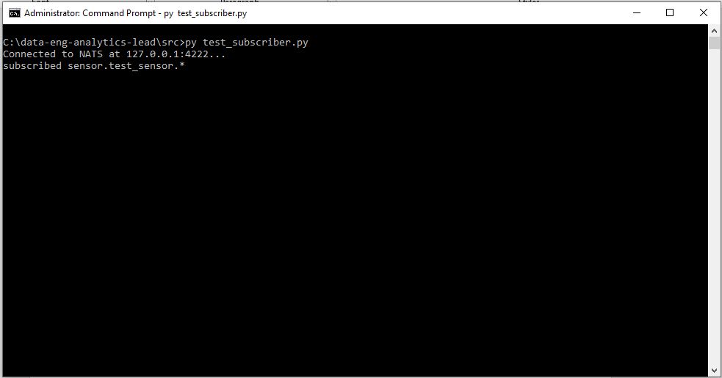

1. Run the command in the termial from /src/ foler i.e “py data_generator.py”. This code will publish the calculated data on the topic “sensor.test_sensor.power” and we can see the calculated value i.e current * voltage which has been received from the two sensors based on the time.

